Predict Wine Quality with Regularization
Short name: WineReg · Python / scikit-learn · n = 1,599 red wines · 11 chemistry tests + binary quality

Problem Statement
The UCI red-wine table rates bottles 1–10. This lesson cuts at 5: quality = 1 if the score is above 5 (855 good / 744 bad, prior 53.5%). Implement unregularized logistic regression, show that the scikit-learn default (historically L2 at C = 1) does not shrink this card, tune ridge C, and use a lasso path as feature selection. Operational question: which of the 11 tests still earn a place on the daily panel?

Solution Strategy
StandardScaler → 80/20 split (random_state = 99) → penalty=None scored with F1 → default L2 → coarse C grid {10⁻⁴ … 1} → GridSearchCV on logspace(−4, −2), 5-fold F1 → validate on the frozen test fold → LogisticRegressionCV (L1, liblinear) and read which weight hits zero. Alternates, threshold / subset practice, and a knob-driven simulation sit in the notebooks.

Solution
Model | Setting | Hold-out F1 | Note
Unregularized | penalty=None | 0.727 | train F1 0.773; alcohol +0.90 SD
Default L2 | C = 1 | 0.727 | identical — constraint too loose
Coarse ridge | C = 0.001 | 0.741 | best of the 5-point grid
GridSearchCV L2 | C ≈ 0.00206 | 0.735 | CV F1 0.773; AUC 0.811
L1-CV (full n) | C ≈ 0.260 | — (fit on all) | density coefficient = 0
Alcohol and sulphates raise P(good); volatile acidity and total SO₂ lower it. Density is collinear with alcohol and extract, so L1 drops it.
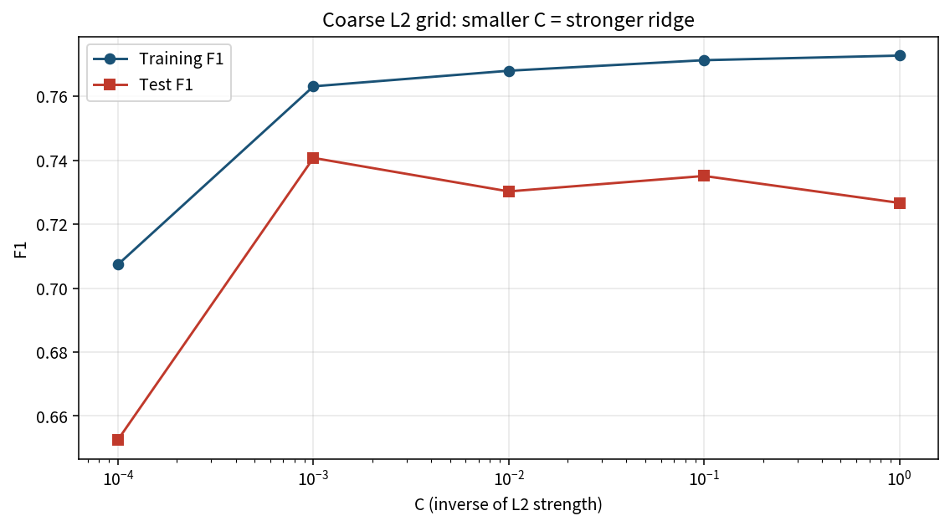

Key Takeaways
- Scale before you penalize — C acts on coefficient size, not on chemistry units.
- Default C = 1 did no work on this card. Turn C down into the 10⁻³ window.
- Tune C on training CV; quote the frozen test fold separately (0.735, not 0.773).
- L1 zeroed density. That is feature selection, not a claim that density is unmeasurable.
- F1 mid-0.70s is a screen, not a 1–10 sensory score, not a price model, not a white-wine model.

